Approach for synchronizing registration ids to server

# Background

Enrolment packets created by the enrolment clients will be periodically uploaded to the server for processing. Before sending packets, client will sync registration Ids with server to let the server know about packets being sent.

The target users are

* Client application, which will synchronize the packets created in client with server.
* Server application, which will store sync information.
* Administrator of the platform who may need to verify the sync info.

The key requirements are

* Rest api to get sync ids from client.
* Save list of sync ids along with details in DB.
* Check if the registration id is available in sync table before picking a packet for processing.
* Update status in sync table after picking a packet for processing so that client can know status.
* Update status in sync table after packet is successfully processed and unique id is generated.

The key non-functional requirements are

* Performance: Should add hundreds of records in db per second.
* Availability: The sync service should have high availability.

# Solution

The key solution considerations are -

* Rest endpoint to synchronize registration ids to server. Create SyncRegistrationController and provide a post method to support sync.

URI: /v0.1/registration-processor/registration-status/sync

* A service which supports following functionalities –
  + A sync method to support registration id sync.
  + A method to check if given registration id is present in sync table.
* Use Kernal services to check if the registration id is valid before saving in table.
* Use Kernel BaseRepository to save the information into table (refer to class diagram for detailed info).

DB Script -



* PacketReceiverService should call SyncRegistrationService to check if the registration id is present in sync table before picking packet for processing.
* Audit/transaction wherever applicable.

Class Diagram:

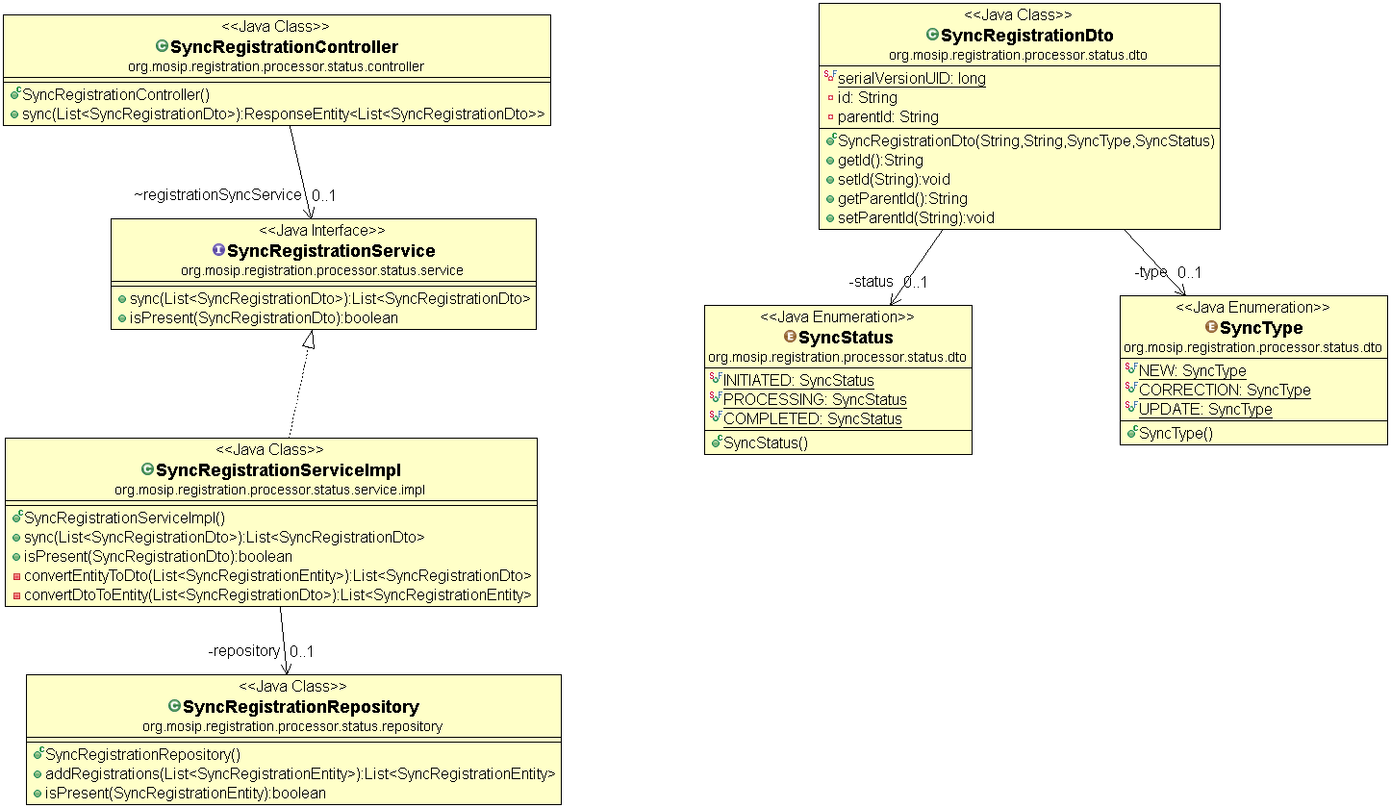

Sequence Diagram:

REQ-1

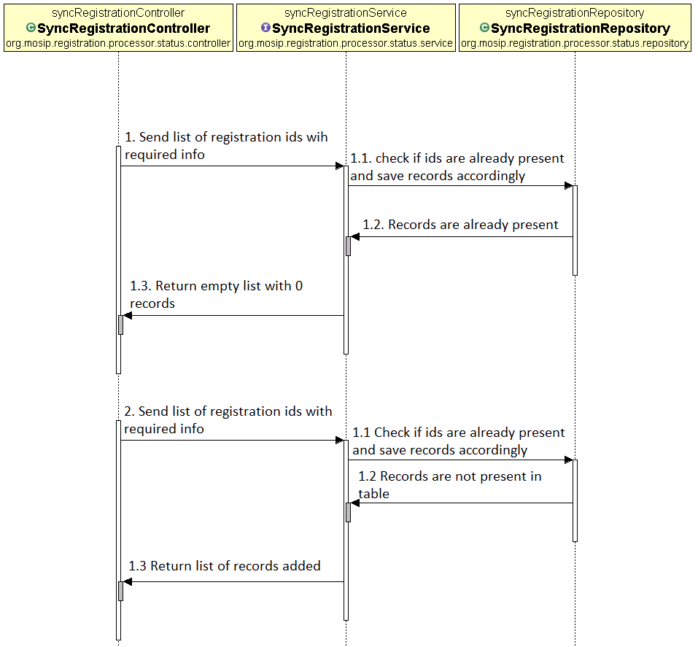

REQ-2

